Minecraft Modding Notes Doc

Matthew

July 13 2022

The Minecraft Modding camp uses MCreator. It will require a Minecraft Java edition account to participate in Multiplayer activities on the last day and to run fully exported mods locally. I highly recommend that anyone who runs this camp be familiar with Minecraft at the very least. I also would recommend that anyone running this camp use MCreator and try and go through the first day on their own. MCreator as a program isn't too difficult to understand, but it is useful to know how everything works and where the buttons are. On this page are links to more detailed notes for each day of the camp. I have also included a general overview of each day here as a quick reference. I have also linked at the top to any other notes related to this camp.

## Other Notes

* Block - Describes everything about the Block mod element. Good reference if you don't understand any properties on the blocks. Also a good reference as to level of detail that should be included in potential notes on every mod element for a club type setup.
* Setting up computers - Has a list of the programs needed for each computer and how to set everything up. Also has instructions on clearing the computers for a second running of the camp. Have all of the computers set up before the camp starts
* Texture Making - Describes everything to do with making textures. Same as the block, this is what I would be doing for everything in MCreator for club notes.
* General Camp Notes - Just my general notes around the camp as a whole. Some of it is personal taste/advice, so feel free to ignore it.

## Day 1

* Day 1 Detailed Notes
* Intro - expectations, what is this camp, center rules, bathroom locations etc.
* Talk about textures - give an overview of how textures work in Minecraft
* First block - make our first texture and then block in MCreator
* First recipe - make a recipe for our block
* Break
* Ore quiz - find some kind of ore quiz online or Minecraft related quiz/activity as a short activity after break
* Ore/Ingot - make an ore/ingot that generates in the world
* Free create with any time left

## Day 2

* Day 2 Detailed Notes
* This day is very busy, but everything should be possible to get done.
* Tools - make tools quickly using the tool pack
* Armor - make armor quickly using the armor pack
* Material pack - make an ore/ingot/block/armor/tools really fast with the material pack
* Break
* Talk about biomes - give an overview of biomes both in real life and in Minecraft
* Make biome blocks - make all the textures and blocks needed for our own biome
* Make biome - make our biome and go find it in game
* Free create with any time left

## Day 3

* Day 3 Detailed Notes
* Custom tool effects - we will add code to a tool that makes it give you a potion effect while you hold it
* Ranged weapon - making a bow and arrow type of weapon
* Ranged weapon 2 - making a snowball type of throwable item
* Break
* Talk about mobs - talk about mobs and how their textures work and what they are in Minecraft
* Mob skin - make a mob skin in minecraftskins.com
* Mob - make a mob in MCreator and edit it's AI
* Free create with any time left

## Day 4

* Day 4 Detailed Notes
* Potion - make a custom potion that gives multiple effects at once
* Painting - make a painting with any image from google
* Food - make our own food item
* Break
* Total free create time. They have time to add to their mod as much as they want, just know that tomorrow we won't be working in MCreator we will be actually playing our mods
* If more structure is needed for the second half of the day, there's notes for a Dimension. Also useful if anyone asks how to make a dimension or they really don't like the potion/painting/food stuff

## Day 5

* Day 5 Detailed Notes
* This day will change based on who's running the camp, but here's the general overview of what I was trying to do
* This day is basically a structured free play or free create day is the goal
* Talk about how Minecraft mods actually work behind the scenes
* Export our mod (both zip and jar for flashdrives to take home)
* Load our mod into Minecraft
* Play with our mod in Minecraft for a while, whether in survival or creative mode
* Snack break can go here, or after the next thing
* Play minigames on a multiplayer server
  + For my camp, I plan on starting a server at my house that they can join from CodeNinjas that has a minigames map downloaded.
  + Hypixel and Mineplex are common servers that they could play on for a bunch of minigames, however they can't really play together easily on these servers.
  + This is really at the discretion of those running the camp, how do you want to structure this final play day?
* Minecraft challenges
  + Do challenges within Minecraft. e.g. who can find x block the fastest? Who can reach the Nether first? Also can do things like Build Battle.
* This day is not set in stone at all, change it to fit your needs. MCreator does have more things to do, I just don't have notes on them!

# Minecraft Modding Camp - Code Ninjas

* It'll be useful for every sensei in the camp to have messed around in MCreator at least one time and have gone through themselves and figured out how to do most of the things the camp will cover. e.g. figure out how to make a texture, block, ore, tools, and add effects. Basically every sensei should know how to do Day 1 on their own and mess with it a bit. It's Minecraft, its fun
* Always manage expectations, a lot of these kids might come in thinking "I'm gonna make my own version of the Aether mod". They're not, definitely not anything that big in a week. They will get to make lots of cool stuff, and making stuff that big is always a possibility, but stuff like that takes a lot of time. We essentially don't want kids getting upset when they can't fully execute on their plans because either A) they don't know how to or B) not enough time.
* Do your best to not give priority to anyone, e.g. if one kid has a bunch of cool ideas we can't help JUST that kid. Also related we can't be doing all the code on these things for them. If they have ideas, HELP them make these ideas a reality, but don't do it all for them. I like to show them how to get started or help them get started and let them do the rest once they know a process.
* Setup the computers BEFORE camp. It will make everything much easier.
* Use faster computers first as much as possible. This is obviously not easy given this camp is usually pretty full but it's worth noting.

# Day 1 - Intro, First Block, and Ore

* Play Minecraft until everyone arrives and gets logged in, just have them log in or use our accounts for singleplayer. don't delay camp start by more than 15 minutes even if someone's late. **ever**. don't. will delay us too much.

## Intro - 5 Min

* Chris will go over general rules
* As an icebreaker we do Name, Age/Grade, How long you've been playing Minecraft OR your favorite block/mob/item/biome/mod/etc.
* Have everyone start up MCreator and go into their Workspace.

## Talk about textures - 10 min

* Close computers halfway while we talk about textures
* How does Minecraft do textures? (ask the ninjas)
* It uses sprite sheets basically, pulling from the sprite sheet whatever face of the block is needed and putting it in the game
* 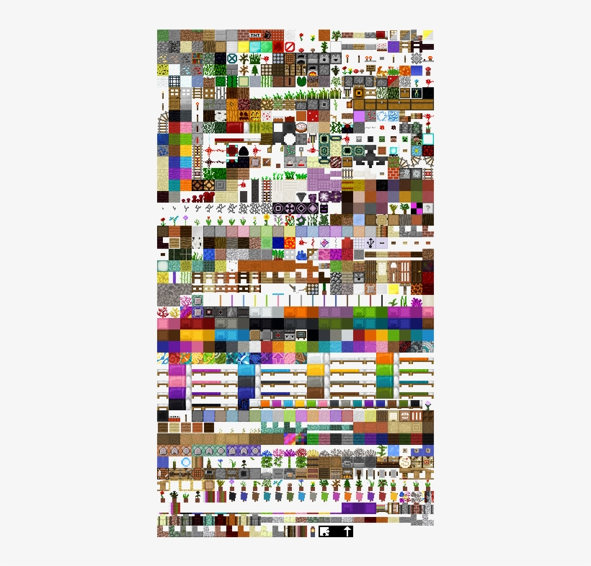
* It also "unfolds" mobs to allow for their full textures to be displayed
* 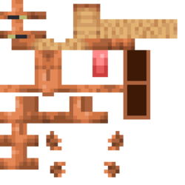
* Can anyone figure out this mob? (ask, I think its a fox I honestly don't know.)
* Google Minecraft textures/Minecraft mob textures and show some more examples. Ask them what they notice and talk a bit about textures.
* Talk more about how Minecraft does textures if you know and/or are stalling for time for some reason

## First Block - 45 min

* First thing we will do modding-wise is make our first block
* We are not making an ore yet! We will definitely do that, but right now we are just getting used to MCreator and what it takes to make things in MCreator
* I recommend breaking the steps down and doing it as follows. Do each bullet point on screen and have them watch it, then have them do that part.
* Make a new Texture
  + Texture Making - full details on texture making
  + Go to resources, create new texture, create texture. There are restrictions on the names for a lot of things, so make sure they pay attention
  + The editor is basically MS Paint, it should be easy to explain and for them to use
* Make block element
  + Blocks - Full details on block mod elements
  + Go back to the workspace, click the Codeninjas Camps/Minecraft Modding/Modding Pics/Pasted image 20220621212248.png green plus and make a block.
  + On the first page (Visual section) they will have to put in their texture, that should be the only thing they have to mess with here
  + On the properties page they can change all the different settings on the block. You can go over some of the main ones like Hardness, In Game Name, and Creative Tab
  + Clicking on the question marks next to anything will bring up a little popup of what that thing does, **Make sure they know this it will save them and you time**
  + Don't spend too much time messing around with properties here, we want to get them to the point of seeing their new block in game.
  + Make sure that before moving on everyone has the texture set up right, the in game name set up, and the creative tab set to something other than none
* Test It!
  + Codeninjas Camps/Minecraft Modding/Modding Pics/Pasted image 20220621212732.png
  + Once they have saved their mod element, press the green play button located in the top right
  + This will open up a version of Minecraft with their mod already loaded into it.
  + They can make a new world to test in, go into their inventory, and should be able to find their block
  + Once you have confirmed that everyone is able to get their block in Minecraft, you can move on
* Messing with properties
  + Ask about the properties that the ninjas found (if any ended up with time to change them) and see what things they noticed
  + Go to the properties tab on the block and look more in depth at some of them.
  + Give them a little bit of time to change some properties, save, and test them out!

## First Recipe - 25 min

* After messing around with the block properties, we will now be making a Recipe for our block!
* Recipes - Full details on the recipes
* Make a new recipe and name it
* It'll bring up a crafting grid like this  
  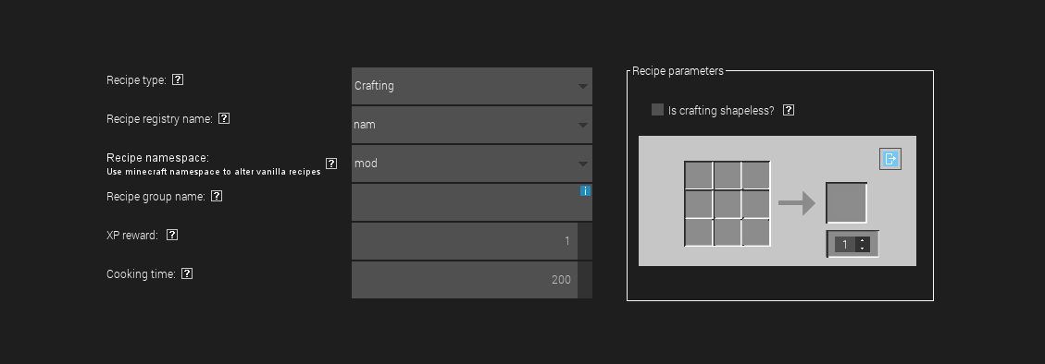
* They can click on a spot in the grid and choose what goes in that spot
* They can also choose what goes in the output spot (our new block) on the right, and the amount of that output that is crafted
* They probably all understand how crafting works, it shouldn't be too hard for them to get a grasp of this
* The things on the left shouldn't need to be changed with the exception of the recipe type and cooking time in case of smelting
  + You can show them the Smelting recipes, although they probably won't need to smelt to make their block. That'll be useful when we get to ores if they're asking about it
  + In terms of the other recipe types, after we've made one for the block and tested it they can mess with them as well
* Save the mod element, go into Minecraft, and test the new recipe by actually making it in a crafting table
* Let them go back to MCreator and mess around with recipes and make new recipes for existing things
* They can also make more textures for blocks and make more blocks and recipes for them etc. there's already a lot they could do!

## Break - 15 min

## Ore Quiz - 5-10 min

* judge based on the kids in the camp whether this is needed
* this can be used as an activity to take up some extra time or get the camp to come back together
* if the kids are going a bit slow or need more time then this can be skipped
* [Minecraft Ores Quiz (sporcle.com)](https://www.sporcle.com/games/lmasta/minecraft-underground-ores)

## Ore/Ingot - 60 mins

* Textures
  + Next we are going to make a custom ore that generates *in the world*
  + First thing we need to do is create the textures
  + Go to the resources tab, create a new texture
  + This time we're going to use the template and find an ore template
  + 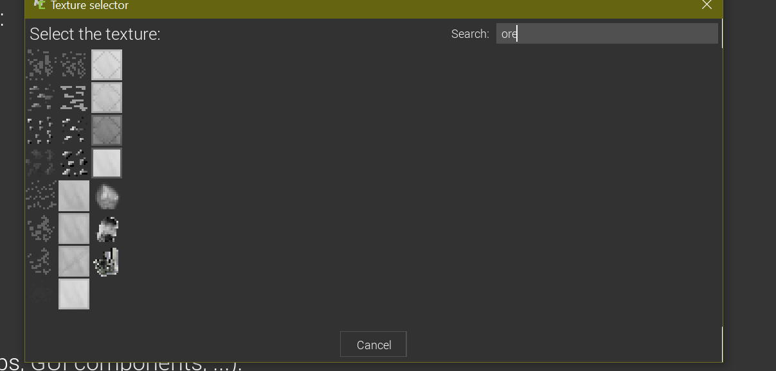
  + They can also choose to create the template from a color or from scratch
  + Make sure they save the texture as a BLOCK and not an ITEM
  + Once the ore has been made, create another texture. For this template, search for either GEM or INGOT
  + 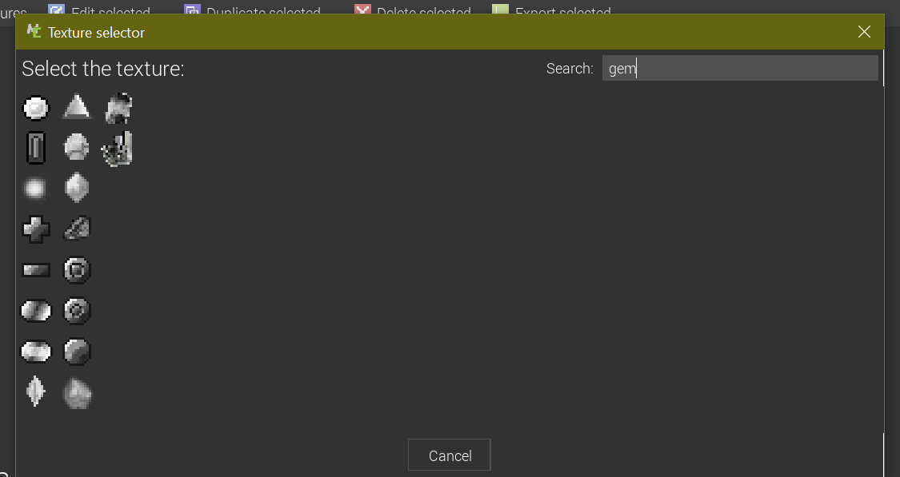
  + 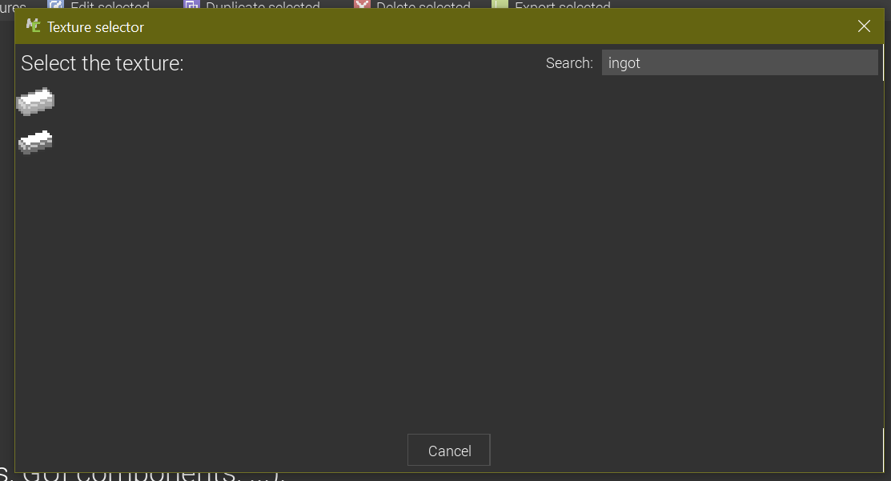
  + They can change the color of these templates however they want
  + When they save the gem/ingot, make sure they save the texture as an ITEM texture and not a BLOCK texture
* The Ore
  + Once the textures have been made, go back to the mod elements tab
  + Create a new block for the ore and edit the properties how they want, mainly theyll want to look at the hardness and tool harvest level to drop. leave the custom drop empty
  + in the generation tab, click this plus and choose surface (thats the overworld)
  + 
  + Average amount of ores in a group can be changed, but as it says it should be less than 32
  + Minimum and Maximum generation height can be changed as they want as well
  + Everything else should be left as default
* The Gem/Ingot
  + Back in the main workspace, make a new Item
  + They can choose the item texture and find the texture they made
  + There's a checkbox for glowing if they want it to glow for some reason
  + The main properties to mess with are the in game name and creative tab
  + Right now we aren't going to do weapons or tools or anything with our new gem, just have it be smeltable
* The Recipe
  + In the main workspace, make another recipe
  + This time change the Recipe type to Smelting.
  + They can then click on the boxes on the right and fill them in with their ore and the gem it makes
  + Save the recipe and hit the play button to test out the new ore!
* Testing
  + They should **generate a new world** in minecraft so that their ore can generate. They can then spend the rest of the time trying to find their new ore.

## Rest of the time

* The rest of the time can be spent searching for their new ore and freeplaying in Minecraft

# Day 2 - Tools, Armor, Tree, Wood, Biome

* There's a lot happening on this day, but it all goes fairly quick
* Play Minecraft until everyone arrives. Start with 10 minutes of free time (camp starts 10 minutes in). This can be changed as needed or liked, I usually like to give some freetime at the start. Reduce time from the Tools/Armor section as needed, they probably won't take 30 minutes anyways but I allocated that much since we had large camp sizes. Break can also be shortened if needed.

## Tools - 30 minutes

* First thing to do is make tools of our ore from yesterday
* Instead of having to make each individual tool, we can use MCreator to make all of the tools and recipes at once!
* Click the Create Tool Pack button 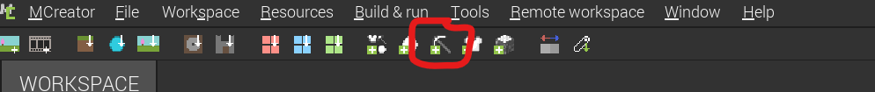
  + Change the base item of the Tool Pack to the gem they made yesterday
  + Add the word "Tools" to the name
  + Change the color if they want to change the colors of the tools
  + Power factor is relative to Iron, meaning 1 should be equivalent to Iron, 2 would be double Iron and so on.
* Once it generates all the tools and recipes, they can go into each tool's item and change the in game name and any other properties
* They can also go into all of the Recipes and change the recipes if they would like
* Have them go in the game and test out the recipes and tools
* Give them time to mess around with the properties of the tools

## Armor - 30 mins

* Creating an armor pack is almost exactly the same as creating a tool pack
* The button is right next to the tool pack one,
* 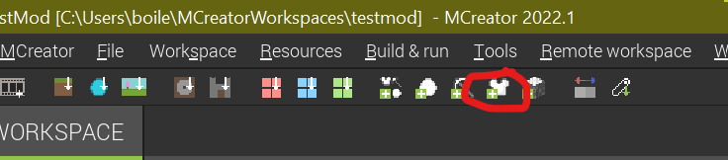
* Choose the main ore/material, choose a color, set power factor relative to iron, and add "Armor" to the name
* Same as before they can edit the recipes and the properties of the Armor
* The Armor shows up as one mod element to edit, you can change the in game names of each item here.
* If they want to change the properties of the armor they can, most of them are explained in their name or the question mark. Only thing they shouldn't change here is the textures
* If they want to modify the textures, it's possible but difficult.
  + Go to resources, theres a new textures for armor section.
  + The item textures and the armor textures themselves are different things that need to be modfied separately.
  + The armor texture is unwrapped similar to the mob textures you would have shown yesterday, which makes it confusing to edit but possible
  + The chest/helmet are on one texture and the boots/pants are on another

## Material Pack (faster making of ore, tools, armor, 20 mins)

* Now that we know how to make and edit both armor and tools, we will show a quick way to make a full ore and set of tools and blocks with it!
* In the same section as the armor pack and tool pack is the Material pack
* 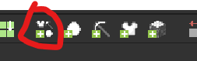
  + The Icon right after that is an ore pack if they just want to make an ore
* You choose
  + name of the material eg. "silver", "diamond", "iron", "ninjaite"
  + whether its a gem, dust, or ingot
  + the color
  + the power relative to iron
* When you click create material pack, it will make a full set of tools, armor, and the ore/ingot for you all at once along with all the recipes.
* They can then go modify all of the generated textures, recipes, and items and change the properties to their liking
* Give them time to mess around with making these and changing properties, finding the ores and etc. to take up any remaining time before break.

## Break - 10-15 mins

## Biomes - 15 mins

* Talk about biomes with the kids
* What is a biome? What is a biome not in Minecraft? (basically have the same answer)
* What kind of blocks do we need in a biome? (wood, dirt, grass, stone, leaves)
* What are some Minecraft or real life biomes? (taiga, desert, plains etc)
* We are going to be creating our own biomes, so think about what kind of blocks and textures you want for it.

## Making Biome blocks - 45 mins

* Create the textures for the following blocks
  + A ground block (equivalent of grass)
  + An underground block (equivalent of dirt)
  + A tree log/stem block
  + A tree leaf block
* Once they make the textures, they can make the block mod elements and change the properties
* Have them test each of the blocks in game and make sure they look good, have the right properties they want, can be used in recipes etc.

## Make Biome - 30 mins

* Go through this once on the screen and have them watch, then do it AGAIN and have them follow along. OR go through it a few steps at a time altogether. Your choice
* Add a new mod element (green plus) and choose biome. Name the mod element whatever the name of the biome will be
* Choose the ground block to be your ground/grass block
* Choose the underground block to be your underground/dirt block
* Leave the underwater block blank
* They can change the name of the biome that will show up in game
* They can change any of the colors however they want, should be obvious what its changing
* Change it to say Custom trees at the bottom and fill in the blocks as appropriate
* Leave tree type as default
* Example biome with everything filled in as it should be (i didnt make proper textures for everything, I just used placeholder blocks). Everything circled can be changed
  + 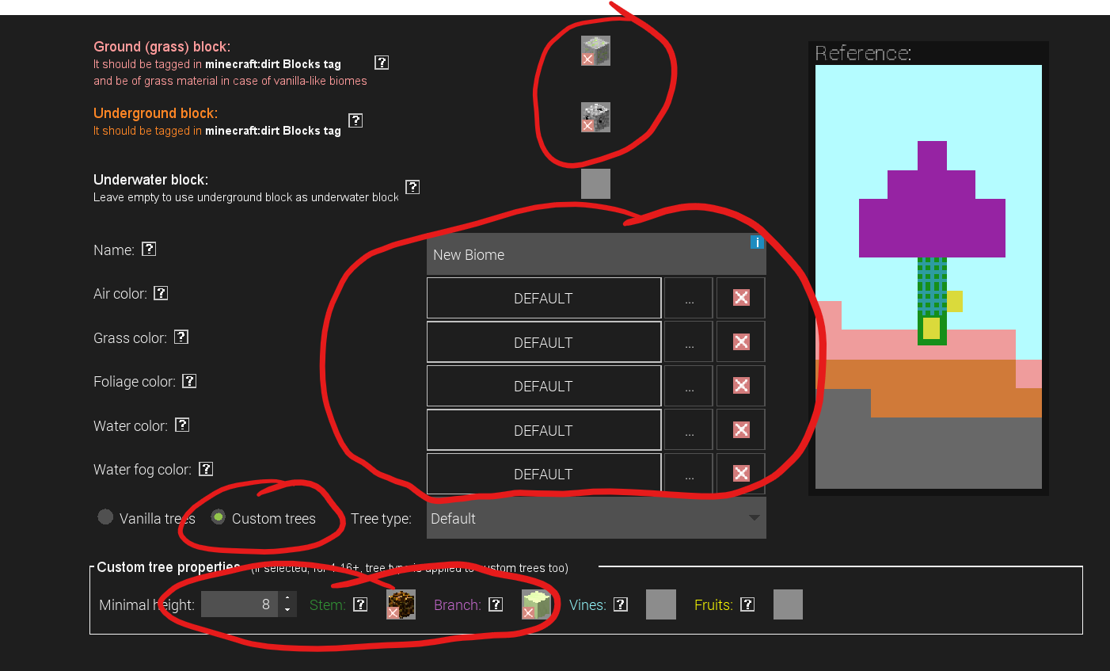
* There are a LOT of properties and settings that can be changed for biomes, make use of the question mark giving an explanation and your own minecraft knowledge to interpret it all
* Here are some of the sections/major properties to change
  + Features - lets you change the number of different things per chunk like trees, grass, flowers and more. **Don't let numbers get set too high, it might crash.** I haven't tested numbers so I don't know where it'll crash at just keep an eye on it.
  + Structures - check off the boxes of which structures can generate in the biome
  + Skip effects, but if they're trying really hard - Lets you change the music/sounds that play in the biome. Also lets you have particle effects that are constantly in the biome.
  + Entity spawning - Click add spawn entry to start.
    - Entity dropdown lets you choose an entity to spawn. Make sure they're not being ridiculous and spawning thousands of ender dragons in the biome.
    - Spawn type - Will this entity spawn like a monster (at night/dark like zombies), like a creature (randomly during the day like sheep), or like bats (ambient)?
    - Spawn Weight - higher number means higher chance this mob spawns instead of anything else
    - Min/max group size - number to spawn at a time
    - Remove this entry - removes the entry
  + Biome generation - Only thing to change here is biome weight, which determines how rare the biome is. Lower numbers are rarer. Also make sure generate in the overworld is checked.
* When they have finished with their biome, have them locate it in game and play in it!
  + Useful command is /locatebiome [press up arrow and then tab auto complete the biome from the list]

## Free create - rest of time

# Day 3 Notes

## Custom Tool Effects - 30 mins

* Have the ninjas follow along or watch as you create a pickaxe that gives you haste while you hold it.
  + To do this, follow everything below, just use haste instead of speed and make the pickaxe texture and tool mod element live
  + This gives them a chance to see it done once or a chance to do it once guided and then do it on their own with a new tool or to their old ones
* Create a custom tool with effects on it.
  + Create a texture for the tool, create the mod element, set up the properties however they want
  + In the triggers section of the tool or item, add procedures to **Living entity is hit with tool** and/or **When tool in hand tick**
  + 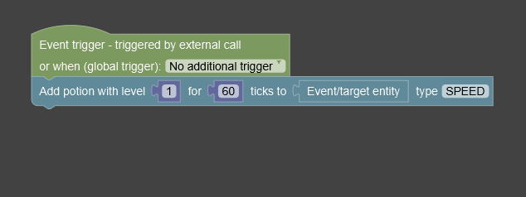
  + The procedure to add a simple potion effect looks like this, they know what the effects all do.
    - For example, the code above will give speed level one for 3 seconds while the tool is in their hand
    - A second is 20 ticks, make sure they keep that in mind when setting the ticks value
  + For a tool in hand tick, use lower tick values so when the tool stops being held, the effect goes away

## Ranged Weapon - 30 mins

* Bow and Arrow type ranged weapon
* Make a texture for your bow part (could be a type of gun, bow, crossbow etc), **save as Item texture**
* Make a texture for the projectile (bullet, arrow etc) **save as Item texture**
* In Mod elements, create an Item for the projectile. Only give it the texture, don't change any other settings for this item, the damage is set by the Ranged item mod element
* Create a Ranged Item
  + Choose the texture they made
  + Item Animation, what the item will act like when they use it.
  + Max stack size 1
  + Item for ammo, set to the item they just made
  + Shoot constantly while active - optional for their weapon
  + Item usage count - durability
  + they can change the sound if they want
  + Under the projectile settings at the bottom, they can change the power, damage, knockback etc.
  + Main thing to change there is the **Item representing texture of projectile**, change it to the item/texture they made.
  + Triggers if they want to mess with them
* Add recipes for both the ammo and the weapon

## Snowball Type Item (with bonus code) - 30 mins

* Examples could be, dodgeballs, pokeballs, stones, anything you can throw basically
* Make texture for the snowball type thing **save as Item texture**
* Create a ranged item
  + Set the max stack size to something other than 1, it's how many can be in a stack. eg snowballs can have 16 in a stack
  + set item animation to none
  + set shoot constantly while active to true
  + **set item usage count to 0**
  + set the sound if they want to change it
  + **IMPORTANT PARTS HERE**
  + Set the item for ammo to *anything* and the **Item representing texture of projectile** under projectile at the bottom to anything.
  + After they save mod element, go back into it and set those two things to the ranged item they just finished making.
  + basically MCreator won't let you choose the item youre currently making, so they have to save it and then go back in to choose that item
  + Rest of the settings act the same
  + Recipe as per usual
  + As a bonus to use some more time if needed, we can add some code to spawn a mob where the projectile lands
    - In the Triggers section, we make a procedure that runs When projectile hits block.
    - 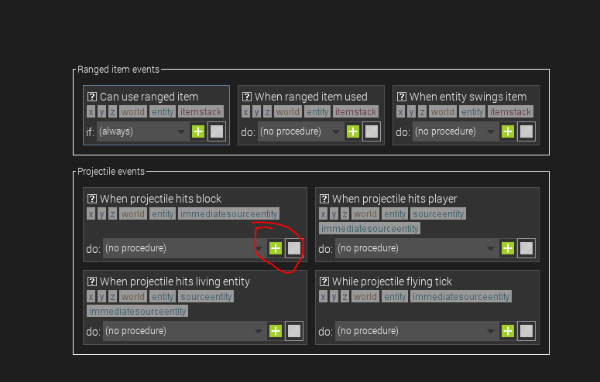
    - Press that plus button and then create with the default name
    - The code will look like this
    - 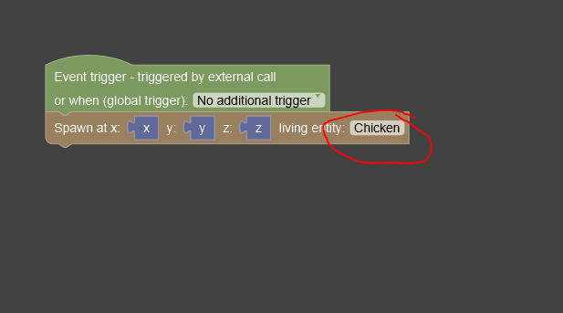
    - They can change the living entity to any Minecraft mob they know of
    - They're also welcome to mess with the code more and try making different things happen, some of the older campers might be able to make some cool things.
    - Encourage experimentation, show maybe placing a block at the x, y, z, instead of spawning a mob. (It's a "Place x at x y z" block, under Block Management section). Try making it do effects when it hits something instead of when it hits a block, like the custom weapon before.

## Break - 10-15 mins

## Minecraft Mobs

* Talk through these questions and have the ninjas answer them
* What are Mobs in Minecraft? (They are animals, creatures, enemies etc)
* What are some examples of mobs? (Sheep, Drowned, Ender Dragon etc, don't let them get TOO off track b/c they probably will)
* What Mob groups are there? Which mobs have similar AI? (Passive - sheep, cows, Neutral - bees, wolves, Aggressive - zombies, skeletons, Wandering - bats)
* We talked about mob textures on day one, but quickly review them here
  + 
* We know Minecraft mobs have textures unfolded kind of like this. Player textures are also done the exact same way. Because of this, we can use any player skin as a Mob skin and turn it into a mob.

## Mob Skin- 30 mins

* First thing to do for this is go to [www.minecraftskins.com](https://www.minecraftskins.com/)
* Click **editor** at the top
* **VERY IMPORTANT STEP HERE MAKE SURE THEY DO THIS**
* They need to click the button that says **Outer layer** and turn it off, or else the texture they' make wont work right in MCreator.
* Screen should look like this 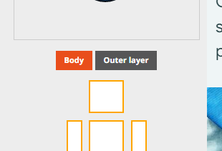'
* The tools should be pretty self explanatory, but theres pencil eraser, eyedropper, bucket zoom etc
* Left click outside of the skin to pan around the skin and color in all parts
* Once finished download it and save it to downloads folder, download button is on the right
* Have them make a skin for the mob they want to create. Some examples could be a new type of zombie, a herobrine type mob etc. basically anything that stands on two legs and looks kind of like a player.
* Making textures for any other kind of mob is difficult, as such we are only able to make mobs that look kind of like players. However, the AI of these mobs can be like any other mob in the game. You could have a standing Pikachu, but the AI is like that of a Wolf.

## Mob - 45 mins

* In MCreator, add a Living Entity mod element (green plus)
* They should not mess with the Entity Model section at all under visual and sound, nor the glow texture or the bounding box. I'd also recommend against the sounds, but they can if they want.
  + Only use the default sounds in the game, don't try and download new ones.
* Make sure they choose their entity texture by clicking the green plus next to it and going to downloads and opening their texture they made and then select it from the dropdown
* In the behavior section they can change some of the general behaviors, same thing as the usual properties they can click the question mark to see what it does.
  + **Important one at the top of Mob or Creature (aggressive or passive).**
  + They can edit the drop and equipment here too, even using their own items.
* I'd skip particles and definitely skip inventory. Triggers are questionable, if you come up with ideas you're welcome to show them
* In the AI and goals, you can show off what some of the AI goals do, but the main thing to do here is get rid of everything except the top block and then click **AI Templates** and choose one to use, probably Basic passive, aggressive towards player, or aggressive when hit.
* Under the last section spawning they can change whether their new mob spawns like monsters, creatures, etc. That's the only setting they should probably change on this page, but as per usual the question marks can explain the settings more.
* Once they have made a mob, go in the game and spawn it. Play around with it, try editing properties, make more mobs etc.

# Day 4 MC Modding Camp

## Potion - 30 mins

* Make a **potion item** mod element
* Name the different potions at the top, add effects at the bottom.
  + The duration is in ticks, so 20 ticks per second * x amount of seconds = the duration they want
  + Amplifier increases the level
* There's no way to change the color of the potion that I can see, its just auto generated

## Paintings - 20 mins

* Download any image from the internet, save it to downloads (somewhere they can get to)
* Make a new painting
* Click the plus to add a new image, find their image
* Click the dropdown and choose their image
* The hardest part about this is the painting size, it lets you choose any size but paintings usually go across full blocks
* A single block is 16x16, so if they want it to be a 2x2 of blocks, it needs to be 32x32 pixels, if they want it to be a 4x4 of blocks, 64x64 and so on.
* Quick conversion table
* Width X Height in MCreator/in pixels ----- Width X Height in Minecraft/Blocks
  + 16x16 --- 1x1
  + 16x32 --- 1x2
  + 32x16 -- 2x1
  + 32x32 --- 2x2
  + 64x64 --- 4x4
* I don't think Minecraft does any other sizes, but you get the idea those are the intervals

## Food - 30 mins

* Owen said that when he did the camp they really liked making new food items, so I figured leave this for last and let them mess around with it the most and make what they want.
* Food stuff is pretty basic, it's make texture **save as Item texture**, make Item mod element, go to food properties and make it a food and change the properties

## Break - 15

## Free Create - rest of time

* If more structure is needed or another goal is needed, go through dimensions

## Dimension - Can be moved to replace Potion/Paintings instead or if those are done too quick

* They will need textures for the item used to light the portal and for the portal itself
* Also will need a block to use for the portal frame, have to make the block mod element if they are making their own
* Properties
  + I'd recommend normal world gen
  + Set a main filler block and fluid block
  + Add any biomes they want to appear in this dimension (could even be the ones they've made)
  + Sky/fog color can be changed
  + Whether to allow sleeping or not
  + All the check marks are kind of obvious
* Portal Section
  + Make sure dimension portal is enabled
  + Portal frame block - this is the equivalent of obsidian for the nether portal
  + Particles - the particles coming off the portal
  + Luminance - how much it lights up
  + Igniter item name - name of the item used to ignite the portal eg flint and steel
  + set the textures for the igniter item and the block at the bottom
* As far as I can tell there's no way to craft the item for the custom portal, it'll have to be a creative only thing i think
* This entire thing is likely to be buggy but if they wanna do it the option is there

# Day 5

## Minecraft Mods explanation

* How do Minecraft mods actually work?
  + Minecraft mods are written in a language called Java, as is Minecraft itself. We make mods in MCreator which turns the mods into code for us automatically.
  + Right click any mod element and open it in the code editor to see the actual code that makes that mod element work. Be careful, editing this will make it not work!
* What is Forge?
  + Forge is a modloader for Minecraft.
  + Basically Forge is able to read the files that mods are saved in and lets Minecraft actually accept them

## Export mods to .zip

* We will first export our mods to a .zip file. This lets you continue editing your mod at home, so long as you download MCreator.
* They will need to follow along closely
* In MCreator, first click Workspace at the top, then Workspace settings.
  + Rename the mod to whatever they want to call it. **ONLY CHANGE THE IN GAME NAME**, leave the other names as they are for ease.
  + Click "Save Changes" when done
* Click "Export Workspace to a Shareable ZIP". Careful, since the one below that is very similar but not the same.
* Save the file to the Desktop for ease, and have them name it their name
* When saving mods to flashdrives they can put that file on the flashdrives

## Export mods to .jar

* In MCreator, on the top right click this icon
* 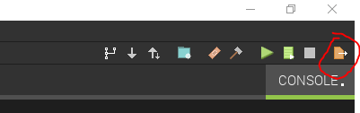
  + Everyone will be exporting their mods at once, which may take some time
  + A popup will come up asking for donations. Click "Export the mod without donating"
  + 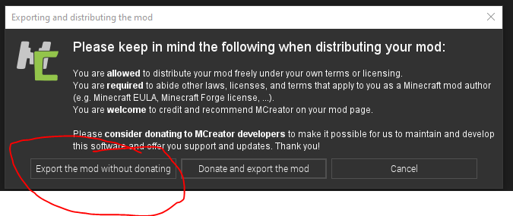
  + Save the mod.jar file to the Desktop again and have them name it their name
  + This file can also be put on flashdrives when parents arrive

## Load mods into Minecraft

* Close out of everything and go back to the Desktop
* On the bottom left of the screen should be a search bar. Click on it and then type "%appdata%" without the quotes. Then press enter. It will open a folder. Have them wait here while you check and make sure they all got it.
* In this folder, double click the .minecraft folder. Then double click the mods folder. (If you did optional setup stuff their might be other mods here already)
* Copy the mod.jar file from the Desktop into this folder, then close out of it.
* A lot of people will likely need help with these steps

## Play mods in Minecraft!

* Open up the Minecraft Launcher
* Click on the bottom left where it probably says "1.19" and change it to the forge installation. Then they can click play and let it load!
* Now that they are in Minecraft, everything is just like the dev environment just now it has their mod installed and its their own account

## Multiplayer server minigames

* I personally will have a server setup with a minigames type of map from my house that people can then connect to
* The other option is to have them play Hypixel or Mineplex or any other servers. However, these can't be done with other people as easily.
* They will need to go out of their modded Minecraft and change it back to 1.19 regardless
* Play some Minecraft minigames together basically

## Minecraft challenges

* Do various Minecraft challenges like
  + Who can do x the fastest?
  + Build battles
  + Most amount of x gathered in 10 minutes

## Programs needed

* Java (newest version)
* Minecraft Launcher
* MCreator
* Forge (file is downloaded and then it installs into Minecraft)

## The process

* Search for Java, if it's not there install it. Otherwise just go to Check For Updates and check for any updates
* Go to %appdata%, delete the .minecraft folder. This wipes all existing mods, worlds, and account info so don't do this if you need to save any for any reason
* Open up Minecraft, log in to your account, play 1.19
* Let it download and load
* Quit game, Google minecraft forge, download 1.18 installer latest (will lead to an ad thing, just hit skip in the top right once it waits)
* Run the file it downloads, Install client. Install. Let it install
* Go back into Minecraft Launcher, run the forge version once
* Change version back to 1.19 (not as important), logout (very important)
* Open MCreator
  + If there's any existing files go to C:/Users/codeninjas user/ and delete MCreatorWorkspaces
  + If it says there's an update do the update and uncheck the box that says Keep caches or something
    - It will have to remove the old version and then install the new one, it's weird
  + If it's empty and doesn't ask for an update then it's all good
* Lastly open MCreator and create a Workspace named something kind of weird or funny or using a random generator or something
  + Making workspaces in MCreator can take a REALLY long time, it's best to have this done before camp starts and have them rename when exporting

## Optional, you don't have to do this I just think it'd be cool

* Install some popular 1.18 mods into Minecraft so they have extra stuff to play with on the last day. Don't tell them this, just make it a surprise!
* Popular mods I would use
  + Biomes O' Plenty - adds a bunch of new biomes and blocks to the game
  + Alex's Mobs - adds a bunch of new creatures to the game
* You can google mods and download them form CurseForge. Place the .jar files into the mods folder. Make sure the mods are good for the version of Minecraft you are using and are good for Forge.
* This is totally optional, don't try and do it if you don't already know how.

# Textures

Textures in MCreator are made using an MS Paint style of drawing canvas.

* To make a texture, first click the Resources tab on the left side 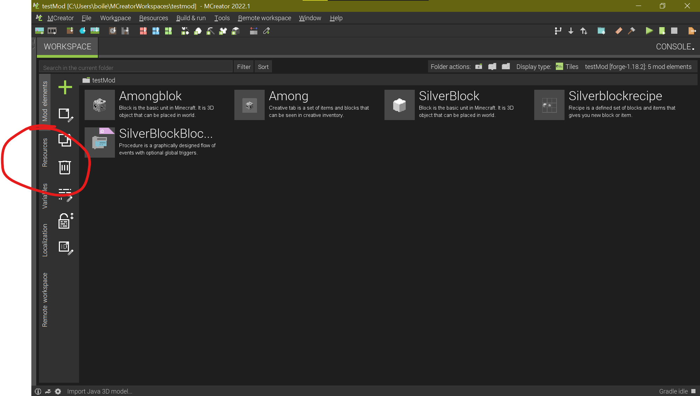
* You then click the Create New Texture button, and then click Create Texture at the top to get this menu 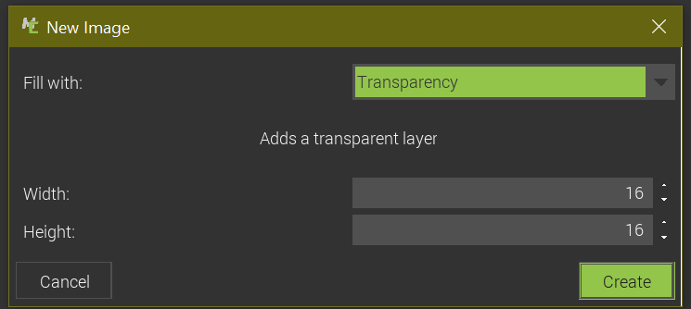
* The Fill with options
  + Transparency - doesn't put anything in
  + Color - fills the canvas with whatever color you use
  + Template - click in the box it makes to choose a base texture to draw on and change the colors of. When making the first block in Day 1 don't use this option, use the other two
  + No layer - don't use this, it creates a completely empty texture and it's confusing
* Width and Height should stay as 16, since that's normal Minecraft texture sizes
* The options and brushes are on the left.  
  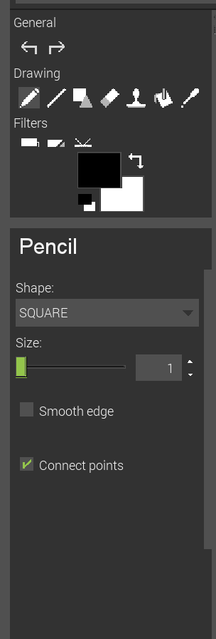
* There's undo and redo, pencil, line, shapes, eraser, stamp (not useful imo), bucket, and eye dropper. All work exactly as you expect.
* You can change colors by clicking on the color and choosing a new one. The tool properties are below that (where it says Pencil in the picture above). All fairly obvious.
* Drawing is easy, just left click. Like I said it's MS Paint.
* When you're done hit Save as New Texture or Save this Texture in the top right
* It'll ask you for a name for the texture. There are certain restrictions on the names, make sure they follow them!
* 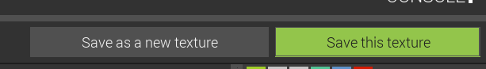
* To go back to the main mod menu click on the X in the tab for the texture (if its still open) and then click Mod elements on the left

# Block

* Create a block mod element, click the green plus and click Block
* Enter a new name for the block, there are certain restrictions to follow make sure they follow them. Also try not to include the word "Block" in the names
* Also do not use existing block names, e.g. Dirt, Diamond etc.

## Steps to actually make a block

1. Make new block texture - Making Textures
2. Make block mod element - above
3. Change blocks texture - Visual
4. Change blocks properties - Properties
5. Save - top right corner Save Mod Element, green button

Following is a description of all the different tabs that are at the bottom. You can navigate to each of them by clicking each of them. The ? next to each thing will give some information when you click on it.

Codeninjas Camps/Minecraft Modding/Modding Pics/Pasted image 20220621174417.png

## Visual

* For the block textures, double click on each blank area and it'll let you choose from the textures that have been made. If you choose a Normal Block model on the right side, it'll let you choose textures for each side. This should be the setting by default.
* The Block Tint will apply the same tinting that applies to Grass blocks and Leaves etc.
  + The Tint Block Item? will apply the same tint to the actual item
* Block Base and Block Item Texture should be left alone always.
  + The Block Item Texture just lets you choose an item texture for the block, if they really want to do that for some reason.
  + The Block base setting is used to make stairs, slabs, leaves etc., but I need to look into how the textures need to actually be made for this
* For Block Model just leave it as Normal or Single Texture, the other options don't do much for us. Single texture applies the same texture to all sides. Normal lets you choose textures for each side.
* Rotation Mode lets you choose how the block rotates it's texture if it's placed from different sides.
* Waterloggable only works on stairs, slabs, leaves, etc.
* Transparency should be left as default
* Special information empty

## Bounding Boxes

I don't know anything about these, avoid them for now

## Properties

Most of these are self explanatory or are explained by the ?

* In-game name - the name that shows up in game
* Material - Block material defines some base block properties such as reaction to pistons, water, plant growing options and more. If you intend to use the block for ore, select ROCK material so the harvest level is properly applied.
* Creative Inventory Tab - what tab it shows up in in creative menu
* Hardness - higher value = longer to mine block
* Resistance - resistance to explosions
* Slipperiness - 0.6 is default, increase it to make it more like Ice
* Jump Factor - 1 is default, higher number increases jump height while on block, lower decreases
* Speed Factor - 1 is default, higher number increases speed while on block, lower decreases
* Luminance - Light level the block emits, from 0 to 15. 0 is none, 15 is like glowstone
* Light Opacity - how much light travels through the block. 0 means all light goes through, 15 means none goes through
* Has Gravity? - obvious
* Can walk through? - obvious
* Glowing? - obvious, glow like magma
* Is replaceable? - replaceable like flowers
* Custom Drop - what item the block drops. If left empty, it'll drop itself
* Drop amount - obvious
* Don't use loot table for drops
* Don't use creative pick item
* Tool able to destroy it - what tool is good at breaking this block?
* Tool harvest level - use the ? to understand the number
* Is Unbreakable?
* Sound set leave as default, or change the Vanilla sound set to whatever sound set they want, it changes the sounds when you break it, place it, walk on it etc. to be like the type of block they choose. Don't use custom sounds

## Advanced Properties

Use the ? for these if they're really wanted, but most of them are beyond the scope of the camp.

## Block Entity

Beyond scope of camp

## Energy & Fluid Storage

Beyond scope of camp

## Triggers

Triggers

## Generation

* Use Uniform distribution
* Click plus for dimensions to generate in, add Overworld
* Change average amount of ores in a group to a number between **1 and 16**
* Minimum and Max generation height are exactly what they say